Sales Fundamentals

**Learning Objectives**

* Describe the overall phases of a sales process.
* Explain how to perform prospect research.
* List and define possible motivations, as well as enabling situations for change.
* Describe ways to establish credibility and obtain commitment.
* Explain the elements of post-sales activities.
* Describe the importance of process in sales activities.
* Itemize steps in the process for obtaining commitment.

Introduction

* How to be an effective sales professional

How many salespeople do you think there are in the world today? The answer? Somewhere around eight billion. That's right, we are all salespeople. If you're speaking, you're attempting to influence, and that's what salespeople do, influence others. So why are some people better at sales than other people? Because they influence others for a mutual benefit, and they understand how to solve customers' problems. That's what this course is all about. My name is Jeff Bloomfield, and I've spent my entire career coaching and developing salespeople. What I've found is like anything in life, the best salespeople tend to do things in a very specific way that always starts with the fundamentals. I want to share with you what it takes to have the right mindset. I'll cover the important difference between providing a solution versus just a product. Finally, I'll share how to create an effective process that you can use to help improve your sales skills and drive results. See, being a great salesperson isn't about control and manipulation. It's about having a genuine desire to help other people solve problems. This course is designed to give you the tools you need to be successful. Let's get started.

1. How to think like a sales professional

* Cultivate your sale mindset.

Whether you've been a professional salesperson for 30 years or you just started your first sales job yesterday, the number one thing that will ultimately determine your success day in and day out is right between your ears. It's your mindset. Recently, I was speaking with a salesperson who was attempting to convince me to use their service for my company. After our brief, hello, how are you, thanks for taking the time to speak with me, introduction, this salesperson launched straight into their pitch. It was all about how great they were and a list of facts about how their solution was the best. Within the first five minutes, I was starkly reminded of the distinct difference between a typical salesperson and a true sales professional. We've all experienced at one time or another someone trying to sell us something we didn't see the need for nor want at that moment. It's the pushy, over aggressive, self-focused salesperson that perpetuates the stereotype. The reality is sales is a noble profession. In fact, without it, the economy would grind to a screeching halt. Most salespeople wake up every day with fear. Fear of rejection, fear of failure, fear of not hitting quota, et cetera. It's that very fear that drives us inward in our focus, and that mindset causes the unintended consequence of distrust and disconnect with our customers. The number one job of any sales profession is ultimately to solve the customer's problem. The issue, however, is that many of us have been trained over the course of our sales career on how to ask leading questions, look for opportunities to present the facts, features, and benefits of our solutions before we've earned the right or the trust of the customer. The most successful salespeople are individuals who have a mindset of what I call the three S's. What can you do to better understand the customer and their perspective? How can you look through their lens to gain a better view of their world? It may be cliche, but how can you attempt to metaphorically walk a mile in their shoes? The more you do this, the more empathetic you will become. And this servant mentality will come across to the customer loud and clear. Now, once you've done your best to view the world through your customer's lens, you arrive at the second S, which is to share your experience and knowledge, as well as the experience and knowledge of other customers who've had similar problems. Now, once you've served and shared effectively, you've earned the right to help the customer with the third S, and that's solve their problem. The order matters significantly. This process of serving, sharing, and then solving builds authentic trust up front, and leads the customer to a place where they genuinely want your help to solve their problem because they trust you. Assuming you now have the appropriate solution to help them, you've made a new customer and likely a new friend in the process. So, here's a few key mindset evaluation questions to ask yourself. Do you genuinely care about other people's problems and find that you're typically empathetic towards them? Do you often share great ideas with others around great experiences that you had? Maybe it was a great movie, a new restaurant, et cetera. When others share their problems with you, do you instinctively think of and potentially offer solutions to help them? If you said yes, then you already have the right mindset to be a serving, sharing, solving salesperson. It's actually a lot more natural than you thought, huh? In fact, I believe that everyone in the world is a salesperson. The question is, do you come across in a way that perpetuates the stereotypical salesperson, or are you someone who genuinely likes to connect by following the three S's approach? When you approach your role from the serve, share, and solve mindset, you'll not only see your sales skyrocket, but you’ll also find that your own job satisfaction elevates right along with your numbers.

* Consider the buyer mindset.

- Have you ever thought to yourself, "Boy! I just wish I could tell what my customer is thinking." One of the simplest ways to understand what your customer might be thinking is to consciously evaluate your own thinking when you're in the buyer's seat. Latest neuroscience research has helped us better understand what I call the buying brain. We dive into this much deeper in the advanced course, the science of sales. But I think it's important for you to have a fundamental working knowledge of how your customer is mentally processing you, their issue or problem and your potential solution. We know that people buy from people they trust. They trust people they like, and they like people they connect with. When a salesperson launches into their presentation mode too early, it not only bypasses the customer's mental trust process, but it also actually sends the brain into a place of scepticism and judgment. At the simplest of levels, here's the filter in the stages the buying brain works through - safety, connection trust, understanding, opportunity and credibility. Let me explain further. Let's suppose I just dropped you into the middle of a very large city that you don't know very well. Your brain sensory response system is on overload. From the constant barrage of noise to all the various neon signs and jumbotron advertisements, all in a foreign language. You are continuously scanning every face, every corner of every street, trying to ensure that you are positioning yourself for safety. Believe it or not, your customer's brain works very much the same way. They already view salespeople as untrustworthy and the constant barrage of facts and data or the jumbotron et cetera, has their brain in resist and run mode. Now let's suppose someone walks up to you in the middle of this chaos and says, "Hello, I'm Jenny and I'm here to help you navigate this city and ensure you get to your hotel safely." She goes on to tell you about herself, her family and why she loves helping foreign tourists. Though your defence mechanisms for your environment are still high, your trust in Jenny has started to open you up to her help. She then begins to describe in detail what you must be feeling like in the situation you're in and what you must be worried about. Your defence’s drop further. As you start to follow her, you realize she knows the area very well and quickly manoeuvres you out of harm's way and in the direction of your destination. Essentially, this is the buying brain. It first seeks to avoid danger. Once it feels the danger threat is minimized, it begins to seek out connection points to determine trustworthiness. If it feels connected, then that trust allows it to explore options or opportunities to gain something positive. Finally, it will validate all these previous feelings through the lens of whether or not the salesperson and their company are credible. To positively impact your customer, you must follow the path of connection to credibility. Here's how you can evaluate this process. Can you quickly and genuinely create trust by connecting with your customer through mutual beliefs? This helps drop their defence mechanisms and gets you through the first three stages, safety connection and trust. Can you reinforce that trust through your understanding and empathy of their situation and or issues? Because this accomplishes stage four understanding. Can you clearly show them a path forward that results in their success? In other words, stage five opportunity, options available to them. Can you demonstrate proof that you and your company have the ability to actually solve their problem? This is stage six, credibility. To summarize, it's about creating an environment of safety and trust through connection. Then demonstrating a clear understanding of their issues, being able to clearly and simply articulate the opportunities available and then demonstrating your credibility to help them solve the problem. Following this order is imperative as it allows your customer's brain to work through its normal cascade of processing and sets you up for optimal success. Describe the overall phases of a sales process.

- Chapter Quiz

How can you quickly establish trust?

by establishing a secure payment system

by offering special treatment

by illustrating your previous successes with customer testimonials

by demonstrating commonality of beliefs and values

1. Successful Sales Professionals Are Customer-Centric

* Create a prospecting process.

Recently, I was sitting in traffic along a busy section of road near my home and noticed one of those sign spinners standing out at the upcoming intersection attempting to lure customers to the local mattress store in the adjacent strip mall. When we think of the various sales and marketing approaches, we are exposed to every day, seeing an approach like this reminded me of just how important knowing your ideal customer is. This is certainly the shotgun approach, blasting a message to the masses in hopes that one person out of 1,000 thinks, hey, you know what? I wasn't really interested in a mattress, but suddenly I am. It's not a very effective approach yet companies and salespeople do it every day. Instead of thinking about how many possible people could buy your product if all the stars aligned appropriately. I want you to start thinking about who in the marketplace is your product or service most likely to help quickly and effectively solve a problem, and then work backwards from there. So, what is an ideal customer, anyway? An ideal customer could be described as a customer who values your product or service, a customer whom you can make a profit from. Sorry, folks, but this is a business. You got to make money, or you won't be in business very long. A customer who'd be willing to refer you to other potential customers. Start with the smallest market possible. If you identify a very focused group of potential customers that have the highest likely degree of success with your product or service, you will gain credibility faster and be able to expand your customer base. I'd like you to think of your ideal customer through the ready, willing, and able framework. Let's take a look at them one at a time. First, are they ready? Issue: do they have a problem that they need solved? Awareness: do they know they have a problem? Motivation: do they have a sense of urgency to solve their problem. Next up, are they willing? And this starts with timing. Are they ready to solve the problem today? Are they searching? Are they currently looking for solutions to solve their problem? And finally, are they able? The first category here is money. Do they have the budget to solve the problem? Next is authority. Do they have permission, or approval, or the decision-making authority to actually solve the problem? Now, how do we find these customers that are ready, willing, and able? Start by creating ideal customer personas or profiles? Customer personas include the following information. What's the ideal industry your best potential customer is in? The ideal title or experience that they have. What's the ideal buying cycle for your product? Meaning, is the customer ready, willing, and able to purchase your product when you need them to. And then the ideal location. Meaning, your product or solution is geographically aligned to where your best customer is also located. One of the easiest ways to get started with customer personas is to build them around your best current customers. If you've got a handful of great customers today who love and appreciate you and your product, then you're going to want to clone them. By building your personas around them, you create the exact profile for your next best new customer. Using these customer personas and the ready, willing, and able filter, you should be able to quickly narrow your pool of prospective buyers and qualify them much more efficiently. If you don't have this type of information readily available, talk to the person responsible for marketing at your company. They should be able to provide you these types of profiles. If you're a small business, and you are both the sales and marketing departments, you basically have two choices. First, you can do the research yourself with the help of Google, LinkedIn, and others, or you can hire a market research company to help you build these target profiles based on your input and their expertise. Remember, the key is to find the narrowest group of customers with whom you can develop a quick and effective partnership by helping them solve their urgent problem. And you can expand from there.

* Identify your customer’s issues when selling.

Have you ever been in a conversation with a salesperson where you were amazed at just how focused they were on the product without really the slightest desire to understand what you really needed? I had this happen to me a couple of weeks ago. A salesperson who was selling software, made a call on me. He started off right out of the gate telling me how great their system was and how other clients were just raving about them. He then asked me if I minded if he shared a few of the new and exciting features that their upgraded system could do. You've heard this before. 20 minutes later, I was bored, and he hadn't even asked me one question about my business. When it comes to understanding the customer's issues there are two basic points of reference. The first point is derived from the research you do prior to the meeting. Where you have a pretty good idea of what the customer issues are. The second area of reference is when you uncover the issues while you are actually meeting with the customer. The pitfall many sales professionals fall into is thinking they know what the customer's issues are before they arrive and then spending their time trying to convince the customer why their solution solves the problem. The key is to understand the customer's issues through their lens, not yours. The only way to do this is to ask experiential questions that allow the customer to really dig deep into their issues. If I were the software salesperson I mentioned earlier, here would be a great question to get the ball rolling. "Jeff, in your experience as a business owner what type of activities do you personally spend in a given week that are focused on new business acquisition?" Now notice the question wasn't directly related to his product. By asking me what activities I personally spend on sales, this salesperson is allowing me to elaborate on how I gain new customers. How I answer that question will give him vast amounts of potential gaps in my process that his software can eventually help with. Now, let me introduce you to the easiest yet most powerful framework under the sun that will help you navigate this crucial sales success area. It's called the four I's. The first is to uncover the issue. If there's more than one issue, it's very important to help the customer prioritize them. That way you can address the most urgent issues. The second I to identify is the impact the issue is having on the customer. This is where you will quantify the problem. If you fail to quantify the problem, then the customer won't have a relative comparison to value when you reveal the price of your solution. For example, if the aforementioned CRM software is shown to help convert 20% more customers per week, and I see on average 10 prospects per week, then the solution will help me gain two additional new customers per week. Now, if each customer is worth on average, let's say $2,000 to me, then I will gain $4,000 in new business each week or $16,000 each month just by using this software. Now you can see how important quantifying the issue is. The third is invasiveness. This is really a subset of impact but reaches across the customer's organization and looks for the broader impact the issue may have. The final I is iceberg. This is the giant barrier that has prevented the customer from solving the problem prior to your meeting. Generally speaking, icebergs tend to be knowledge, time, and or budget or money. By addressing this area, you will reveal any potential objections the customer may have as to what will prevent them from moving forward with your solution. So, let's put it all together so you can see the implications of how effective the framework can be. You have uncovered the main issue, which is the lack of new customer growth. You have determined that each new customer is worth $2,000 to your customer, so the impact has been quantified. You have discussed the implications of what could potentially happen if your customer fails to gain new business like the layoffs, et cetera. And you realize through your questions that this customer simply didn't have the knowledge to solve this problem with a solution like your software. You have essentially framed up the problem in the mind of the customer as a $16,000 per month issue. Well, your software system is only $900 per month at full list price. Now, if you were the customer, would you pay $900 per month to gain $16,000 of new business? Where do I sign? Right. Asking insightful questions focuses on the customer's issues and utilizing the four I's framework will position you perfectly as a trusted advisor who is ready to help solve the customer's problem.

* Assess Customer motivations when buying.

We've talked in great deal at this point about how customers make a purchase to solve a problem. That problem can be intrinsic or extrinsic, but either way, when we make a purchase, we feel like we are filling a need. Regardless of what we are buying, there are particular triggers or motivators that push us over the edge from window shopper to new customer. These motivators are key to understand as each of your potential new customers will have one or more that will need to be met in order to secure well, your order. These are no particular order, as each buyer will be different. The first motivator we will discuss is price. How much something costs can be and in many cases is a large motivator in a buyer's decision. As with all purchases, I can use this to justify why I don't purchase or why I do purchase. For example, I may go to the mall looking for a pair of jeans and find that the pair I like the best costs $120. Something deep inside of me just can't muster the motivation to justify that type of price for a pair of jeans, so I pass. The very same day, my wife and daughter go to Kohl's where the unimaginable happens, a sale. They end up spending $250 on clothes that they never even intended to buy but found themselves so compelled to do so because of how much they were saving. I mean, come on, they save $200 on that $250 cart full of clothes. The more commoditized a product is, the higher likelihood that price will be a strong motivator. The next motivator that tends to go along with price but is much deeper, is value. People who are motivated by value are weighing the benefit of your product or service compared to the price that you're asking. The higher that perceived value, the more I'm willing to pay. Next up, we have quality. This motivator tends to go hand in glove with value. The difference between the two is where value is a perception of benefit versus price, quality is strictly the perception of calibre of the product or service. Let's use the iPad as an example, if I were buying strictly on quality, then price and value are not that important to me. My perception that the iPad is the highest quality tablet will drive my purchase, regardless of price. If I were motivated by value, I may decide that the level of quality between the iPad, a Surface and maybe a Kindle Fire are similar enough, so I would likely buy the Kindle Fire because the price to value ratio is higher in my mind. The fourth motivator is self-preservation. This scenario is when I feel that I must make a purchase in order to secure a promotion, prevent a demotion, or simply in more practical terms, protect my family or myself. This motivator is driven primarily by fear and is a highly emotional motivator. In a business-to-business sales setting it's very difficult to uncover this motivator. Finally, the last motivator we will cover is social pressure. Many people buy products today based on who they know personally has recently bought the same product. This motivator derives from the group think mentality and the subconscious feeling of the need to fit in or belong, to not miss out. Many products today have gained mass market appeal simply by leveraging the motivation of social pressure. Why do you have the cell phone you have? What about the car you drive? How about the neighbourhood you live in? Many subconscious factors go into the social pressure motivator, but it can be a strong ally in your sales approach if your product or service has the type of mass market reputation that creates a buzz in the mind of your perspective customer. These are the primary motivators of why customers buy. Once they know they have a problem and have decided to attempt to solve it, one or more of these motivators will help them pull the trigger. Your goal is to determine through your research and conversation, which motivator is having the largest impact on their decision.

* Identify barriers to change when selling.

I remember when I finally decided to switch from a Blackberry to an iPhone. I'd seen many of my peers utilizing this new cool technology and I could see the buzz around me at every turn. And the iPhone was out for nearly two years before I finally made the switch. Can you think of something that you've recently changed? Satellite provider, cell phone carrier, insurance. Change is hard for the vast majority of human beings, isn't it? Getting your customer to change is equally as hard. Let's talk about the change process and then go a little deeper into the barriers that prevent us from changing. In order to change, in particular from a consumer standpoint, we go through what I call the purchase change equation. Awareness plus motivation plus ability equals change. Step one is, does your customer have the awareness that they need to change or even that other options are available? The next step, step two, is how motivated are they to make the change? Is there enough pain, et cetera? Change seldom occurs until the pain is staying the same, exceeds the pain of change. Let that one sink in. Step three, how easily can they implement the change? If you have a great product or service, but your lead times are six months out, you've made it much more difficult for me to change to your product. Even though the right level of awareness combined with the right level of motivation and the ease or ability to implement leads to the greatest likelihood of change, there are still several unconscious barriers that we all have to accepting change. The first is anxiety. When faced with a change human beings tend to get really anxious. They do this due to the fact that they have the subconscious feeling that they're going to take a risk and don't know what the outcome will be. So, what's the solution? Ensure there's trust in the relationship first, and then be mindful to continually speak to what the customer can expect from your partnership. Remove the unexpected and unknown and you'll remove the anxiety barrier. The next barrier is the feeling of isolation. When faced with change, humans tend to draw inward and feel isolated. We don't do this consciously. It's at a subconscious level. It stems from our internal fight or flight mechanism in that we need to hunker down and get through this change. So, what's the solution? Ensure the customer understands how many other customers have been in their exact shoes and the results they have experienced by working with you. In addition, provide them with direct access to a couple of really satisfied customers who will walk them through their positive experience. Do this successfully and they will move from a feeling of isolation to an excitement of being part of something that's already successful. The next barrier is the feeling of potential loss. Because humans primarily view change as bad, especially change that we didn't choose ourselves, we tend to look at the change cup as half empty rather than half full. As a result, we start looking for things we will lose or have to give up to make the change. It's part of our self-preservation mechanism buried deep within our subconscious. So, what's the solution to this? Make sure you're using positive language that continually highlights what the customer will gain by making the change. The next barrier customers face is we can only take so much change at one time. Our brains are wired to handle only so many changes at once. If you try to sell more than one solution at a time to your customer, they may start to feel overwhelmed and not end up buying anything. What's the solution to this? Focus the customer at one incremental change at a time, baby steps is the key. The next barrier is when the pressure to change is off, we tend to revert back to our old way. So, referring back to the change equation, if my awareness is high, but my motivation really isn't. Then the minute you walk out of my door no matter how excited you made me feel about your product, I will likely go right back to doing business the same way as before you came. What's the solution? Make sure you spend enough time really diving into the customer's issues and spend as much time as necessary quantifying those issues. That will drive up the motivation and urgency and the likelihood that they will make the change then and there. So, in summary, it's really about your ability to help navigate your customer through the awareness plus motivation plus ability equation all while keeping in mind the five subconscious potential barriers to change. Do so effectively and you'll ensure the sale and create trust and loyalty in the process.

* Chapter Quiz

Question 1 of 7

Rupa spends time honing her research on a customer's needs. She arrives for the first meeting with a customer, and immediately presents several potential solutions. What is Rupa doing wrong?

Rupa should question the customer first.

Rupa should establish credibility first.

Rupa should prioritize her list of solutions according to price.

Rupa should ascertain whether the prospect has buying authority.

1. Successful Sales Professionals Leverage Solution Selling

* How to position your product when selling

- So, in my house, my wife and I have different responsibilities. I'm responsible for fixing stuff. I can remember years back when our hot water heater went out. How do you think I was feeling? More importantly, what do you think my wife was feeling? See, we simply wanted to have hot water again. We needed a solution. To her, do you think she really cared which product I chose? Of course not. All she wanted was a solution. As I'm sure you've realized by viewing previous chapters, it's critical to look at sales through the lens of your customer. Like my wife, they are looking for solutions also. Products and services are simply the vehicles that delivers the solution. Let's look at the formal definition of a product versus a solution. A product simply defined is an article or substance that's manufactured or refined for sale. Makes sense, right? A solution is defined as a means of solving a problem or dealing with a difficult situation. See the product may be the means, but the solution is most certainly the end. People buy solutions, not products. Now I'm not sure about you, but where most salespeople run off the rails is that they try to sell products instead of solutions. They communicate the facts and the features and the figures and the opinions around the physical characteristics of their products, rather than the process of arriving at a positive solution for the customer. So, let's look at two examples. In example one, we will highlight a product-focused salesperson. In example two, we'll highlight a solutions-focused salesperson. Okay, you ready? So, you walk into the local home improvement store and ask to talk to someone about a new hot water heater. A sales guy from the plumbing area comes out and says, "So I hear you're in the market for a new hot water heater." "Yes," you say. "Well, we have several to choose from. They range from 40-gallon capacity up to 75-gallon capacity, as well as a life range of three years up to 12 years. We have natural gas and electric, depending on what you need. Prices are around $300 up to $900. So which one you think you'd be interested in?" And you say, "Well, gimme the cheapest one a guess, for 300 bucks." Now let's try it from a solutions approach. Same exact scenario. This time the salesperson asks, "So why are you in need of a new hot water heater? Is this a replacement or is this for a new home?" And you say, "Well, it's for a replacement." "Okay, great," he says. "Tell me a little about your house. How large is it?" And you say, "It's 2,500 square feet." "Great," he says. "How many people do you have that live there?" "Five." "Great. Would you say that hot water tends to get used at one time or spread out over the course of a day? For example," he says, "in my family, the vast majority of hot water gets used between six and eight in the morning." And you say, "Well, ours is very much the same." "Okay, great," he says. "That helps me understand how much capacity you are going to need so that the last person in the shower still has hot water. Finally, are you more concerned about the price of the water heater or the energy efficiency?" He then takes all that information and makes two recommendations based on his own experience and what he would do for his family. So, as it turns out, the 50-gallon six-year energy efficient water heater for $650 is the choice you end up making. Why? Because the second salesperson sold you a solution, whereas the first sold you just a product. The difference between a product salesperson and a solution salesperson is night and day in both their approach as well as their commission check. So, here's what I want you to do. Take a moment and make a list of all the solutions your product or service solves. Next, I want you to think about how you can ask better questions to get your customers focused on the solution to their problem first and then use your product to solve it.

* How to Frame your solution when selling

- What is it that distinguishes you from me? You may have black hair where I have blonde. You might be 5'9" where I'm over 6' tall. You may have long hair where mine is short. You get the point. It's our features that are the obvious initial characteristics that allow us to tell one person from the next. In certain circumstances, the benefits of those features may allow for one person to have an advantage over another. Let's look at an example. If we're going to play basketball and you're now over 7' tall and I'm just over 6' tall, that feature provides you with a distinct benefit, which allows you to have maybe a higher reach, longer wingspan, et cetera. That gives you a distinct advantage over me in basketball. And if you were a basketball coach, you would find that feature a key element in your evaluation of which one of us you would want on your team. Conversely, the fact that you have black hair, and I have blonde hair, that really isn't a feature that provides a beneficial advantage, especially when it comes to playing basketball, right? Now, when it comes to your product or service, it's critical to understand all your features but it's the benefit of the feature that the customer needs to see as critical to solving their problem. And as importantly, the advantage your solution creates compared to other options that they have available to solve their problem. Many salespeople are wonderful at spouting the facts and data to describe all the wonderful features of their product or service, but great salespeople, they know all the details of their customer's problem they are solving and can relate the benefit of the features of their product plus the resulting feeling the customer gets having used your solution to solve it. They do this while at the same time creating differentiating space from their competition by ensuring the advantage they possess over the competitor comes through loud and clear. Let's highlight the feature, benefit, result, advantage continuum. Let's do so with a real-world example, like the iPhone versus the Galaxy. See, if I were selling the iPhone, I must first understand what you, the customer, values most. Now for me, if I'm the customer, seamless integration of all my devices on the same platform is pretty cool. So as a salesperson, you might say, "One of the best features of the iPhone is how its operating system seamlessly integrates with iTunes, iCloud, the App Store, et cetera." What's the benefit? Well, the benefit of that is having everything all in one place on the same technology. Now, the resulting feeling that I could feel might be this peace of mind that I have knowing everything is organized and fully integrated. The ultimate advantage over the Galaxy is that it's known primarily as a phone that's not part of the Apple ecosystem. Now, you may not like Apple products, but I think you get the point. Here's the application. If you haven't already done so in previous lessons, I'd like for you to make a list of the top five problems that your customers tend to have. Make them problems that your product or service can solve. Next, I want you to list out the top 5 to 10 features your product possesses. Next, after that, next to each feature, I'd like you to list the benefit that feature has to your customer in a way or manner in which it helps solve or leads to solving the problem. Finally, next to that, list the advantage that feature, and benefit has over alternative or competitive solutions your customer might be considering. If you can successfully do this across the board, it will be extremely easy for your customer to see you as the obvious choice for their solution. Now, if you find that you come out on the losing side of each feature, benefit, advantage exercise, you might want to find a new product or service to market.

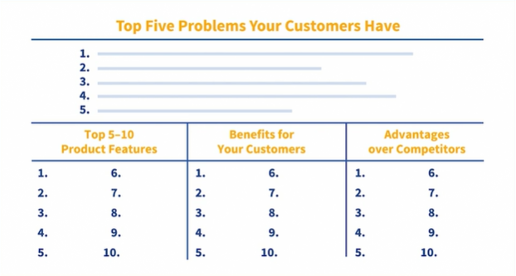

* How to show proof of your solution to customers

Let's say you're in the market for a new HD flat screen TV. Sounds like fun, right? What's the first thing most consumers do? We go to the internet. We aren't there just looking for the various brands and their features. We're actually looking for information that will help us be more confident that we're making a wise buying decision. We want to know that others have bought the same TV and that their experience was great. We want proof. The need for proof that a product or service actually does what it says it does is rooted deep in our brain's subconscious mechanisms that drive self-preservation. We don't want to make a mistake. We don't want to get fooled. That will cause pain, and we like to avoid pain. Proof that a product or solution works helps us minimize that risk. Now, when it comes to the proof of your solution, there are five basic proof sources that you can pull from. The first proof source is that of the expert. Depending on the sophistication of your product or solution, an expert can really elevate the credibility of your solution in the eyes of your potential customers. They're experts in every field. So, it's not a stretch to think that any given solution could use this source. The more technical the solution, the more appropriate the need for an expert proof source. A good example of this would be a doctor helping promote a new drug or supplement. The next proof source is that of a celebrity. Celebrity endorsements are quite powerful, particularly in the direct-to-consumer space. Using William Shatner to promote Priceline or Michael Jordan or LeBron James to promote your shoe and clothing line creates significant credibility, and the desire to buy a solution that well known and well-liked celebrities appear to like and use themselves. In the business-to-business space, celebrity proof sources are much less common. Next up, we have the user proof source. Regardless of the product or service, when you can demonstrate credibility through the eyes of the end user, you generate significant momentum and influence on new customers. Every website on the planet uses testimonials and reviews now to pitch their products. Using case studies and third-party reference stories in the business-to-business space is quite common and can be very effective if done properly. The fourth proof source at our disposal is the wisdom of the crowd. This proof source is like the user proof source but supercharged. Rather than a specific user experience, wisdom of the crowd taps into our deep desire to be a part of something big, as well as our fear of missing out. This proof source uses the mass effect to influence. If billions of people have eaten at McDonald's, then it must be good. If 30,000 people have joined a service, it must work. Volume of customers does equate to credibility in our subconscious minds. Finally, we have the wisdom of peer’s proof source. This technique leverages the known referral source. If you can generate a reference that the new customer's familiar with, you increase the influence factor tenfold. Now, if you're someone I trust and you refer me to someone who has a product or service that I need, I automatically transfer a portion of that trust onto you. This proof source is the most powerful, as it comes from someone the potential new customer knows and trusts personally. One of these proof sources is powerful, but if you combine two or more, you can really differentiate yourself from your competition. Think of the various proof sources you have for your product or service. Create a list of ideas that fall into one or more of the previous categories. Now, I want you to create a strategy to create and communicate these proof sources to your potential customer base. Keep these strategies in mind and you'll have one more powerful tool in your sales toolbox.

* How to support successful solution implementation

A couple of years ago, I was brought in by a client to help them develop a growth strategy and to help them figure out where some of their most glaring inefficiencies lie. They're a consulting company with three primary divisions, sales, delivery, and operations. The primary concern the CEO had, like most CEOs, was new business growth. A secondary concern was that they were losing business both at the implementation stage, which should never happen, but also, they missed opportunities to cross-sell additional products in the post implementation stage. So, as I began to evaluate the situation and talk to both current and past customers, a couple of significant themes started to emerge. First, customers didn't like the fact that a person on the sales team spent all the time building a relationship in order to gain the business, but then seemed to disappear once the sale was made, and then once the project was passed off, the delivery team took over. Secondly, they found the delivery team to be inflexible and not all that personable. Essentially, this client fell into a similar trap that many businesses fall into. They have too many silos in their own organization and don't really understand the full impact those silos have on their customers. Customers want to know three things once they've decided to buy from you. First, that the solution will deliver what you promised, that it'll actually solve the problem, second, that you can implement it effectively and on the agreed upon timeframe, and finally, third, that there's continuity of customer service throughout the relationship. These expectations may sound like complete common sense, but you'd be surprised how many businesses don't operate with high marks in all three areas. All that said, let me give you some ideas that'll help you more effectively implement your solution. First, create a system by which someone on the sales team is the quarterback of the account. They are the single point of contact throughout the relationship. They should know everything that's happening and get regular reports from delivery on how things are going. They should also have regular check-in meetings with the customer throughout the implementation to ensure satisfaction. If your business has salespeople that are simply hunters and then pass it off, you might think about a team approach by which an account manager is with the salesperson every step of the way. The second thing you can do is to cross-train your delivery team on both customer service and sales. Then you can cross-train your sales team on delivery and customer service, and finally cross-train your customer service team on sales and delivery. This will create a team environment and break down the silo mentality that I mentioned earlier. Finally, have a system of customer satisfaction meetings and surveys that happen on a regular basis. I would recommend monthly, but quarterly at the least. The customer may not want to do these, especially if things appear to be going well, but you should bake this into the proposal from the beginning. See, many times a decision-maker isn't aware that a potential problem exists until it's too late. Then you have to try to involve as many hands-on people at the customer side as possible to resolve it. If you have a commodity or retail product, your focus should be on customer service as you likely don't have a delivery team per se. But for all of us that work in the business-to-business space, these strategies are critical to seamless implementation and will set you up for future sales within the same account and true customer loyalty for life.

* Chapter Quiz

**Question 1 of 6**

A salesperson comments, "The difference here is that the faster connection on the Oak II than all competitors permit immediate availability in the cloud." The salesperson is describing a(n) _____.

* advantage
* feature
* all of these answers
* benefit

1. Successful Sales Professionals Focus on the Process

* The value of an effective sale process

I'm going to start this lesson off by sharing my typical morning with you. And you'll see why in just a minute. On a typical day, I wake up, use the restroom, head downstairs, say good morning to my wife and kids if they're up already, let the dog out, make a cup of coffee, make my breakfast, take my vitamins, and read the latest news on my iPad at the kitchen table. What about you? Do you have a morning routine? Most of us do. As humans we actually like routine. The familiarity is actually a stress reducer. Our anxiety in general is lower when we know what's coming next and what to generally expect. If you really stop to think about it, we have these routines across nearly all aspects of our personal life from how we shower and get dressed, to how we prepare dinner, to the homework and evening routine we have with our kids. We have these routines for a very specific reason. We have found that over time, if we do certain things or certain behaviours in a certain order, we tend to get consistent and predictable results. The actual definition of process is, "A series of actions or steps taken in order to achieve a particular end." Makes intuitive sense, right? Why then do we resist these same processes in sales? Mainly due to the fact that the vast majority of salespeople feel that they can create their own process, that they know best. I frequently hear clients tell me their salespeople are experienced enough to not need a rigid process. The problem is all in the conceptual delivery. Nowhere else in the company do people buck, flinch, and complain about processes like they do in sales. You can go department by department in any company and you'll see process after process, except sales. Okay, now that we've called a spade a spade, I want to show you why having an effective sales process is so valuable. The first reason is that it helps create a consistent voice to the customer base. Too many lone sales wolves on the street, all with different ways of doing things, can create confusion to the marketplace and dilute the brand and the overall credibility of the company. The second reason is consistency of results. Every great sales process should create great results. Your sales process is like your game plan or your playbook. Once the players or the sales team understands the playbook it should put your team in a winning position consistently. If it doesn't, then parts of your process need to be evaluated and adjusted. The third reason is really no one has arrived as the perfect salesperson. Nope, not even you, sorry. As a result, we know that everyone has room to improve, and everyone deserves a good coach. When you have a clear sales process, you and your coach can better identify areas of improvement in your approach. When you think of elements of your sales process today, what do you think is working well? What do you think needs to be improved? Remember, there's a reason why you wet your hair before you shampoo it. And there's a reason why you brush your teeth after you eat. And there's a reason why following a clear and effective sales process brings value to you and to your company.

* The elements of an effective sales process

- One of my favourite sports to play growing up was basketball. I can remember the gruelling two-week camps that preceded the season. We ran sprints, we ran more sprints. And then we ran again. We learned plays, ran those plays, and then ran them again. The weeks leading up to the season were quite monotonous and quite frankly, a little boring. I couldn't wait to get to the first game. The first game was always so exhilarating. We worked so hard, had a great game plan, and now got to compete for real. By the end of the night, there'd be a winner and a loser. No two ways about it. The day after the game, we would spend a couple of hours watching film with our coach and he'd point out areas that we did really well, and maybe areas we didn't execute. The next day, we started practice and planning for the next team, and the process started all over again. Essentially, just like most competitive sports, sales has a series of activities that takes place prior to the sales call, then the sales call and then a series of activities that happen after the sales call. The elements of an effective sales process, fall into one of these three categories. The first is the pre-sales activity which falls into two subcategories, planning and preparation. In the planning phase, you perform activities such as prospect identification, product research, industry research, competitor research, and call strategy. In the preparation phase, you take the information you glean in the planning phase, put it into a written call plan, clear objectives and goals, create the appropriate presentation materials and, or tools, build the best stories, anticipate customer objections and practice for the call. Yes, I said it, practice. For the vast majority of organizations., stage one, the pre-sales activity stage, is the weakest link in the sales process. Imagine if I had just shown up to the first basketball game without any of the proper planning and preparation. Sure, my natural skills may have prevented me from looking like a complete fool, but it would be clear to most that I didn't know the plays, wasn't in good shape, and didn't have a handle on the team I was playing. Take this stage seriously, and you'll already have a leg up on most of your competitors who simply show up and wing it. The next stage is the customer engagement stage. This is where the planning and preparation get demonstrated at game time. Customer engagement requires a process within the process to maximize your results. Most sales processes have some form of in-call flow they recommend to the salespeople. The one I teach that has had incredible results for folks, flows like this. Create connection, followed by identify and prioritize the issues, followed by create credibility, followed by solving the problem. You know this as the presentation portion. Followed by handling any objections and it ends with gaining commitment. In the next lesson, we'll help you get more details behind how to put this model to work in your sales process. Finally, in stage three, post-sales activities, is where we close the loop on the process. In this stage, we do things like solution implementation, customer service and support, gather customer feedback, and get the feedback from our manager or coach on what went well and how we can improve the next call. Much like the pre-sale stage, we tend to overlook many aspects of the post-sales stage once we've gained the business. The reality is this stage is critical to your long-term customer loyalty and results in significant increases in cross-selling opportunities. Research shows, time and time again, that it's infinitely easier to sell to a current happy customer than trying to bring on a brand new one. Treat your customers accordingly. These are the three stages, and the elements contained within a good sales process. In the next lesson, you'll begin to build your own or modify the one you have for maximum impact.

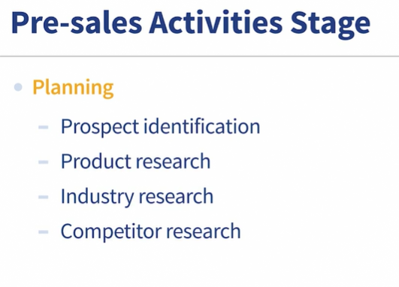

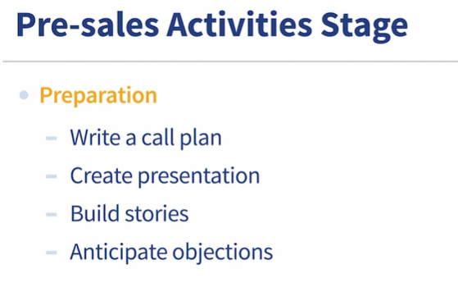

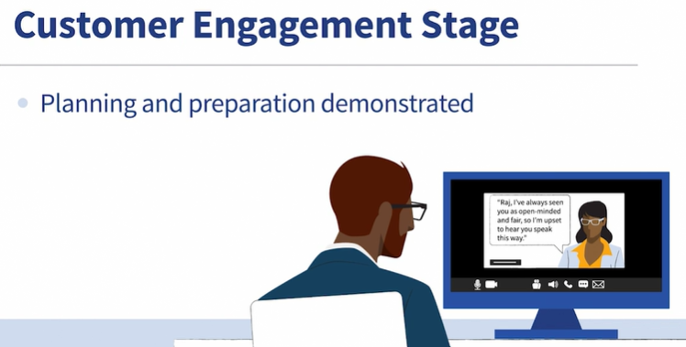

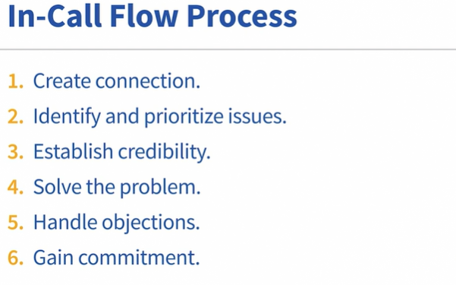

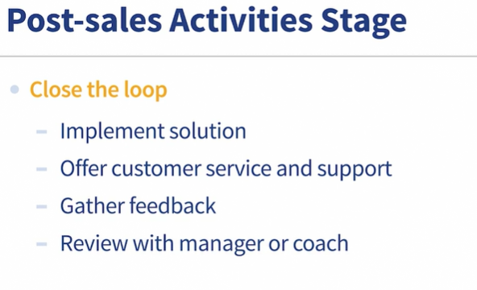

* How to develop and hone your own sale process

All right, for this lesson, we're going to just dive right in. In previous lessons, we discussed the importance of a sales process and the elements of a good one. Now you get to take those elements and design a sales process that works for you. We will build this process around the three stages, pre-sales activities, customer engagement, and post-sales activities. As you build your pre-sales activity stage, it's important to be thinking about what knowledge and skills you need that will support your actual sales call and give you the highest likelihood of success. Make a list of things that you need to know about your prospect. Details like title, industry, current solution provider, maybe buying cycle. How did they engage with you? Or did you cold call them? Or maybe they contacted you in some other way. Next, test your own product knowledge. How well do you know the details of your solution and how it actually solves a problem? What do you still need to know? Who can you reach out to in your company in order to understand it better? How well do you know your competition? Make a list comparing and contrasting your solution with theirs. You should understand their products as well as you understand your own. Now move into the preparation phase. Do you have a written call strategy? What are your objectives for the meeting? Are they measurable? What do you expect to happen after the meeting? What presentation materials do you need? What stories do you plan to leverage? Make a list of potential customer objections and create a story to combat each one should they arise. Lastly, once you've got all this information in a clear and easy to access plan, practice your call with a coach or peer, then review it again on your own visualizing the scenarios. Now you're ready for phase two. As mentioned in a previous lesson, we have found the customer engagement stage works best when you follow a certain order. Step one is create connection. This goes beyond simply rapport building. It requires you to create an introduction story that shares who you are and why you do what you do. For specific examples of how to create this type of story, visit our website www.braintrust101.com. Step two is to identify and prioritize the issues the customer's facing. For more information, refer back to the previous lesson on understanding your customer's issues. Next up, we move into creating credibility. This is where you explain through a company story, why you and your company are the most credible to solve the problem. From there, you solve the problem by presenting your solution. Think about creative ways to do this through stories and analogies and engaging visuals. Don't be boring and don't be a data dumper when presenting the solution. Use emotion and story-based techniques to maximize the customer's engagement. From there you can address any objections the customer may have, but do so through narratives, not facts. Lastly, gain the commitment, get them to decide the next step. Most people call it closing, but I teach folks not to close. If you follow the framework I just laid out, by the end the customers should really close themselves. If they don't, you should reflect back on the steps and see where you might have missed an opportunity. Now you're on to building your last stage. Post-sales activities. Make a list of steps that clearly outline for the customer the implementation steps, simplify things as much as possible, make it easy for the customer to change to your solution. Next, create a customer service contact and resolution process so that you and your customer know exactly what to do should they need help, and exactly how each issue gets brought to resolution. Next, create a customer feedback questionnaire. It shouldn't be longer than 10 questions with a mix of ratings and open-ended comments. The last step in this stage is to create an evaluation sheet for yourself. Your manager likely already has one, but if they don't, create one and give it to your manager. Ask them to periodically go on sales calls with you and use the sheet to give you feedback afterwards. Similar to how athletes evaluate their performance on the field, the feedback from your manager is the game film we all need to review that makes us better each and every call. There you have it. You now have a complete framework for a great sales process. Once you apply the details for you and your business, you'll be in great shape to knock your sales goals out of the park.

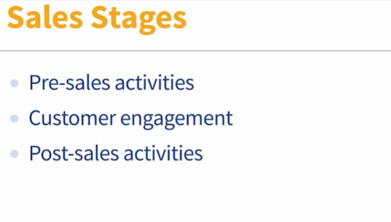

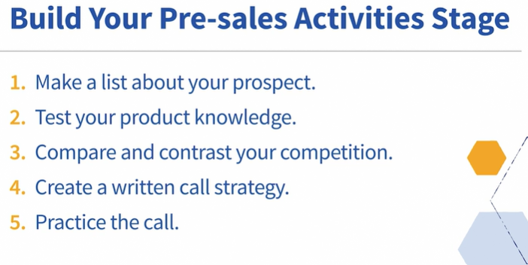

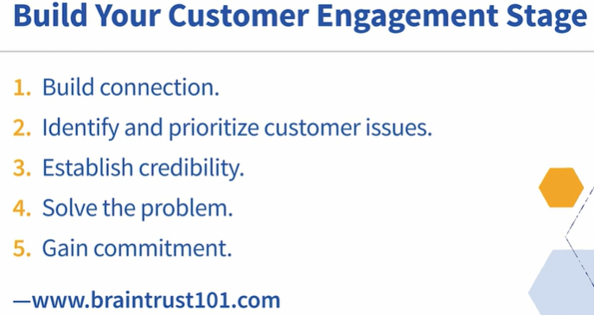

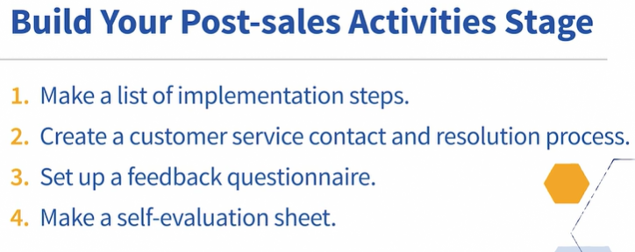

* Chapter Quiz

Question 1 of 6

Why are post-sales operations critically important to sales professionals?

They improve the incidence of prompt payment by the customer.

They make up for product inadequacies.

They foster repeat customers, which are much easier to obtain than new ones.

They reduce the workload for both manager and salesperson.

Conclusion

* Continue your sales journey.

Sales is the foundation of the way we do business. Remember, we're all salespeople. The question is, are you going to be the type of salesperson that helps other solve problems? Cause those are the most successful salespeople. If you'd like to learn more and go deeper on this topic, there are a few resources I'd recommend. First, check out your local chamber of commerce. They typically have monthly programs to help businesses improve their sales. I also have a host of resources available to you on my website, braintrust101.com. There you'll find videos, tools, white papers, and other resources that reinforce the lessons in this course. The salesforce.com blog is also great. This company is more than just a software company. They offer a host of resources that speak to the current trends and techniques in sales and marketing. Hubspot.com is another good blog that's full of creative and relevant information for salespeople. Also, you might want to check out the National Association of Sales Professionals. This is an organization that provides additional resources and community for sales professionals. Sales isn't a journey that you take alone. Connecting with others to learn, share, and grow is key to your long-term success. I encourage you to reach out to other sales professionals that you respect. Having mentors and guides along the way will accelerate your success. Also, if you'd like to connect with me, you can find me on LinkedIn, Twitter, or my website. Join us and become a part of a growing sales community. Congratulations on completing this course, and I look forward to hearing your next sales success story.